Housing Price Drift: Economics of Market Equilibrium Prices

1.) Demand of Housing
Main determinants of the demand for housing are:
- Demographics (Population Size and Population Growth - It is necessary to consider family size, the age composition of the family, the number of first and second children, net migration (immigration minus emigration), non-family household formation, the number of double family households, death rates, divorce rates, and marriages.)
- Income
- Price of housing
- Cost and availability of credit
- Consumer preferences
- Investor preferences
- Price of substitutes
- Price of compliments all play a role

Income elasticity of demand in North America: 0.5 to 0.9.
Price elasticity of the demand for housing services in North America: -0.9 to -0.7

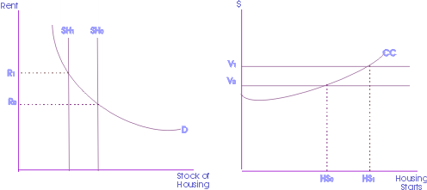

Figure 1: Rent and Housing Stock; Value and Housing Starts

2.) Supply of Housing
The quantity of new supply is determined by:
- Cost of inputs such as land, labour, and various inputs such as electricity and building materials
- Price of the existing stock of houses
- Technology of production

For a typical single family dwelling in suburban North America, approximate percentage costs can be broken down as:
- Acquisition costs 10%
- Site improvement costs 11%
- Labor costs 26%
- Materials costs 31%
- Finance costs 3%
- Administrative costs 15%,
- Marketing costs 4%

Multi-unit residential dwellings typically break down as:
- Acquisition costs 7%
- Site improvement costs 8%
- Labor costs 27%
- Materials costs 33%
- Finance costs 4%
- Administrative costs 17%
- Marketing costs 5%

Supply price elasticity depends on the elasticity of substitution and supply restrictions. There is significant substitutability both between land and materials, and between labour and materials. In high-value locations, multi-story concrete buildings are typically built to reduce the amount of expensive land used.

Supply restrictions can significantly affect substitutability. In particular the lack of supply of:
- Skilled labour
- Land availability
- Land use controls such as zoning bylaws

3.) Housing and Economic Indicators

- Existing-Home Sales
- Pending Home Sales Index
- New-Home Sales
- Housing Starts
- Housing Affordability
- Mortgage Purchase Application Index
- Fixed-Rate Mortgage Rate
- GDP
- Consumer Confidence
- Unemployment Rate
- Consumer Price Index
- Producer Price Index
- Retail Sales

4.) Market Equilibrium
Factors affecting market equilibrium:
- Inelasticity of supply and demand
Generally, market equilibrium is affected by elasticity of demand or supply, or the percentage change in one variable given a change in another. In particular, currently, the price elasticity of demand for housing falls between -0.7 and -0.9, which signifies that demand for housing is relatively inelastic. This data seems reasonable, because housing can be considered a necessity good, as shelter is one of the primary keys to survival. Thus, with the elasticity of demand of housing being relatively inelastic, any shift in the supply curve will have an affect on the ultimate market equilibrium; the demand curve may adjust relatively slowly given a change in supply.

Similarly, the income elasticity of demand falls between 0.5 and 0.9, which exemplifies how housing could have inelastic demand, but only up to a certain extent. One of the biggest factors influencing home prices are income levels. Income elasticity of demand measures the effect on demand given a percentage change in income. Home prices are limited in how far they can rise by the incomes of potential buyers. Since eighty percent of all homes purchased are purchased with a mortgage, the ability to make payments, borrow money, and the cost of borrowing money are major influences limiting how far prices can rise before hitting resistance due to prices hitting levels where potential are unable to qualify.

- Government restrictions on rent

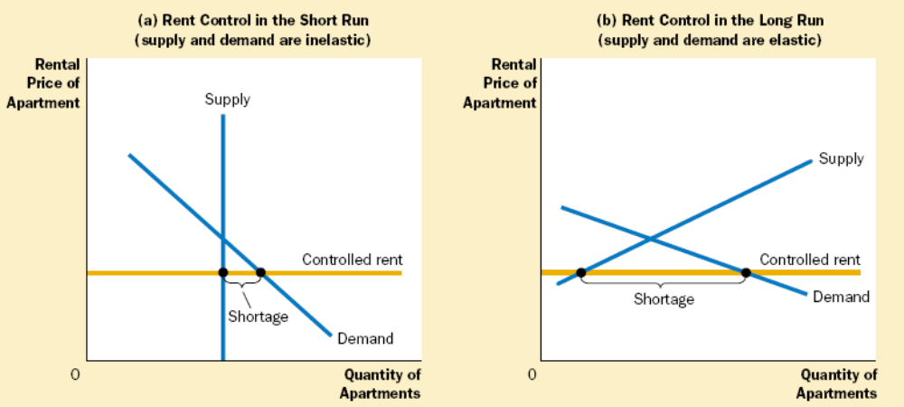

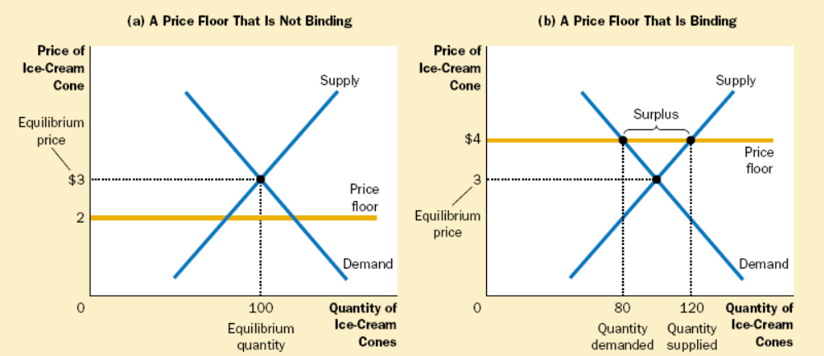

- Taxes and Tax Credits

When a tax is levied on buyers, the demand curve shifts downward by the size of the tax; when it is levied on sellers, the supply curve shifts upward by that amount. In either case, when the tax is enacted, the price paid by buyers rises, and the price received by sellers falls. This causes a reduction in quantity at equilibrium, meaning the size of the market shrinks. In the end, buyers and sellers share the burden of the tax, regardless of how it is levied.

The distribution of the tax burden, or the incidence of a tax, depends on the price elasticities of supply and demand. The burden tends to fall on the side of the market that is less elastic because that side of the market can respond less easily to the tax by changing the quantity bought or sold.

The aim of a tax credit is the reverse of a tax. Tax credits intend to increase the size of the market, as is the case with the tax credits for the Housing Market Recovery Economic Stimulus Package. Current legislation states that first time homebuyers are eligible for a $7500 tax credit, given that they purchase the home after April 1, 2008 and before July 1, 2009. This tax credit is essence an interest-free loan that required repayment over a period of up to 15 years. This month (Feb 2009), Congress passed an $8,000 tax credit for first time home buyers. Note that this credit does not need to be paid back, unlike the original $7,500 first-time homebuyer tax credit. To qualify, the purchase has to be made between January 1st, 2009 and before November 30th, 2009, and the homeowner must stay in the house for three years.

- Other factors
  - Local economic strength
  - State and municipal zoning
  - Neighborhood features (such as quality of schools)
  - Condition of the property itself

5.) Economics of Housing Bubble
- Housing surplus has been created from the era of loose lending standards and low rates has caused a downward decline in prices.
- Demand for housing has dropped significantly, as access to credit has deteriorated.
- By the Austrian Business cycle theory, the bubble was created from a significant increase in borrowing and lack of saving, prompted by overseas borrowing and monetary pumping by the Fed.
- Housing prices have been driven up by the speculative fever, and the prevailing sentiment that housing prices will never drop.

http://mises.org/journals/scholar/Thornton13.pdf

